|  |
| --- |
| **A**  **PROJECT REPORT ON** |
|  |
|  |
| **Garage Management System** |
|  |
|  |
| SUBMITTED IN  PARTIAL FULFILLMENT OF  **DIPLOMA IN ADVANCED COMPUTING (PG-DAC)** |
|  |
|  |
|  |
|  |
|  |
|  |
|  |
| **BY**  **Suraj Porje**  **Tushar Pawar**  **Kiran Padangale** |
|  |
|  |
| **UNDER THE GUIDENCE OF**  **Mr. Digvijay Bhunje** |
|  |
|  |
|  |
| **AT**  **SUNBEAM INSTITUTE OF INFORMATION TECHNOLOGY,**  **PUNE** |

|  |  |
| --- | --- |
|  | |
| **SUNBEAM INSTITUTE OF INFORMATION TECHNOLOGY,**  **PUNE.** | |
|  | |
|  | |
|  | |
|  | |
| **CERTIFICATE** | |
|  | |
| This is to certify that the project | |
|  | |
| Garage Management System | |
|  | |
| Has been submitted by | |
|  | |
| **Suraj Porje**  **Tushar Pawar**  **Kiran Padangale** | |
|  | |
|  | |
| In partial fulfillment of the requirement for the Course of **PG Diploma in Advanced Computing (PG-DAC AUG2015)** as prescribed by The **CDAC** ACTS, PUNE. | |
|  | |
|  | |
| Place: Pune | Date: 23-JAN-2021 |
|  | |
|  | |
|  | |
| **Mr. Digvijay Bhunje** |  |
| **Project Guide** | **Alumni Mentor** |

**ACKNOWLEDGEMENT**

The successful completion of a project is generally not an individual effort. It is an outcome of cumulative efforts of a number of persons, each having its own importance to the objective. This section is a value of thanks and gratitude towards all those persons who have directly or indirectly contributed in their own special way towards the completion of the project. For their invaluable comments and suggestions, we wish to thank them all.

We owe our gratitude and appreciation to our guide Mr. Digvijay Bhunje whose help, stimulating suggestions and encouragement, helped us to coordinate our project especially in writing this report.

We would also like to express our gratitude towards Sunbeam faculty and management for their Extended Support.

Our thanks and appreciations also go to my friends in developing the project and people who have willingly helped me out with their abilities.

**ABSTRACT**

We generally rely on the small and medium scale garages for servicing of our vehicles. However, such automobile garages don't have the benefits of computerization as much as the large size service centers have. Our web system attempts to provide this advantage to such garages so that they can maintain records of the work details of each servicing and also manage better relation with their customers through various offers to the clients. Notification about servicing completion can be provided to the customers. So if network of number of garage on system is increased, it becomes easier to manage them. Being a web based system; it can be accessed quite easily by all users from PCs.

**INDEX**

|  |  |  |
| --- | --- | --- |
|  | **INTRODUCTION** |  |
|  | 1.1 Introduction | 1 |
|  | **Product Overview and Summary** |  |
|  | 2.1 Purpose | 2 |
|  | 2.2 Scope | 3 |
|  | 2.3 User Classes and Characteristics | 3 |
|  | 2.4 Technologies Used | 3 |
|  | **REQUIREMENTS** |  |
|  | 3.1 Functional Requirements | 4 |
|  | 3.1.1 Use case for Administrator. | 5 |
|  | 3.1.2 Use case for Vendor. | 6 |
|  | 3.1.3 Use case for Customer. | 6 |
|  | 3.1.4 Use case for Employee. | 7 |
|  | **PROJECT DESIGN** |  |
|  | 4.1 Data Model | 8 |
|  | 4.1.1 Class Design | 8 |
|  | 4.1.2 ER-Design | 9 |
|  | 4.1.3 Database Design | 10 |
| **5.** | **PROJECT SCREENSHOTS** | 15 |
| **6.** | **TEST REPORT** | 23 |
| **7.** | **CONCLUSION** | 24 |

**LIST OF TABLES**

|  |  |  |
| --- | --- | --- |
| **Section** | **Table Title** | **Page** |
| **1** | **User** | 9 |
| **2** | **Admin** | 9 |
| **3** | **Vendor** | 9 |
| **4** | **Employee** | 10 |
| **5** | **Customer** | 10 |
| **6** | **Feedback** | 11 |
| **7** | **Question** | 11 |
| **8** | **Offer** | 11 |
| **9** | **Service Request** | 12 |
| **10** | **Stock** | 13 |

**LIST OF FIGURES**

|  |  |  |
| --- | --- | --- |
| **Section** | **Table Title** | **Page** |
| **1** | **UML for Admin** | 4 |
| **2** | **UML for Vendor** | 5 |
| **3** | **UML for Customer** | 5 |
| **4** | **UML for Employee** | 6 |
| **5** | **Class Diagram** | 7 |
| **6** | **ER Diagram** | 8 |

**INTRODUCTION**

Garage Management System is a windows application which aims to enables the user to keep track of all the activities of a garage. It is a web based application which helps the user to manage the stocks available in the garage, check for repair estimates, delivery etc. It maintains vehicle service history and mechanic shop time. Our web system attempts to provide this advantage to such garages so that they can maintain records of the work details of each servicing and also manage better relation with their customers through various offers to the clients. It also manages the inventory of the vehicle parts. It shall maintain the database of all the vehicles that are serviced and shall be able to send service notification to customers based on the service dates. It has secured access to admin. The admin shall be able to keep track of different users like supervisor, receptionist, principal etc. It is a smart web UI which could assist the garage owners to keep track of all the events in the garage.

**PROJECT OVERVIEW AND SUMMARY**

**PURPOSE**

The purpose of this project is to provide car or any other automobile servicing system more effectively than the existing system. There are some disadvantages of the existing service center management systems. These disadvantages are overcome by the automobile service center management system. And it can be made handily available to every person. Previously people could not get help or locate the service centers conveniently in case of their car break-down or any other emergencies. Thus GMS is proposed to assist people and fulfill their requirements easily.

This project enables the user to keep track of all the activities of a garage. It is a web based application which helps the user to manage the stocks available in the garage, check for repair estimates, delivery etc. It maintains vehicle service history and mechanic shop time. It also manages the inventory of the vehicle parts. It shall maintain the database of all the vehicles that are serviced and shall be able to send service notification to customers based on the service dates. It has secured access to admin. The admin shall be able to keep track of different users like supervisor, receptionist, principal etc. It is a smart web UI which could assist the garage owners to keep track of all the events in the garage.

**SCOPE**

* Currently vehicle servicing management has become a tedious job.
* Small and medium scale garage, service centers have to manage data about customers, services offered to them.
* It is difficult for small scale businesses to maintain data for longer time as they are using paper based system.
* Customers also need to find nearest garage which provide authentic service.
* Using this system they will be able to maintain customer and services data.
* Also multiple services centers which are using the same system will be able to synchronize their work.
* We are also solving the problem from customer's end by making ease of choice. They can choose the service center nearby their location.

**USER CLASSES AND CHARACTERISTICS**

In this software, there is an Admin. Admin can add new vendors to the system which is another module of software. Vendors can add new Employees which is also another part of system. Employees can create job card for customer. Customer can use the software for registering to the system. Customer can book the servicing and can opt for pick and drop service.

**TECHNOLOGIES USED**

MySQL

Angular

Spring Boot with JPA

**REQUIREMENTS**

**FUNCTIONAL REQUIREMENTS**

The major functionality of this product is divided into four categories.

* Administrative Functions.
* Vendor Functions.
* Employee Functions.
* Customer Functions.

In this application each and every user must having their own Email ID and Password, using these Email ID and Password only they can directly enter into their corresponding Login forms.

System analysis will be performed to determine if it is feasible to design information based on policies and plans of the organization and on user requirements and to eliminate the weaknesses of the present system.

1. **Administrative Functions.**

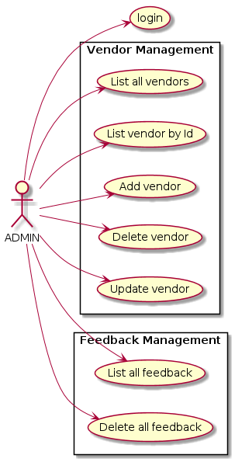

1. **Vendor Functions.**

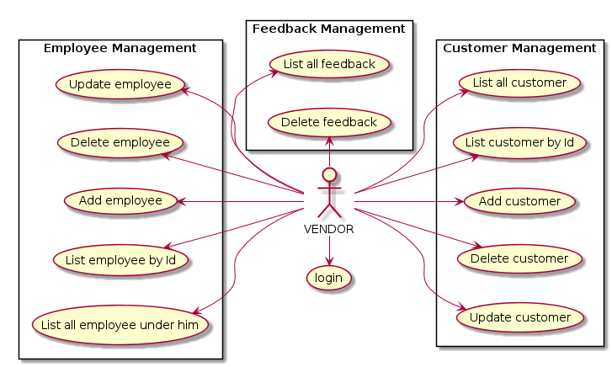

1. **Customer Functions.**

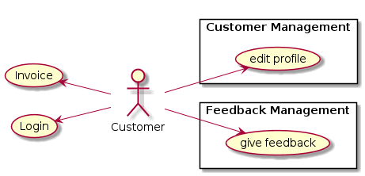

1. **Employee Functions**

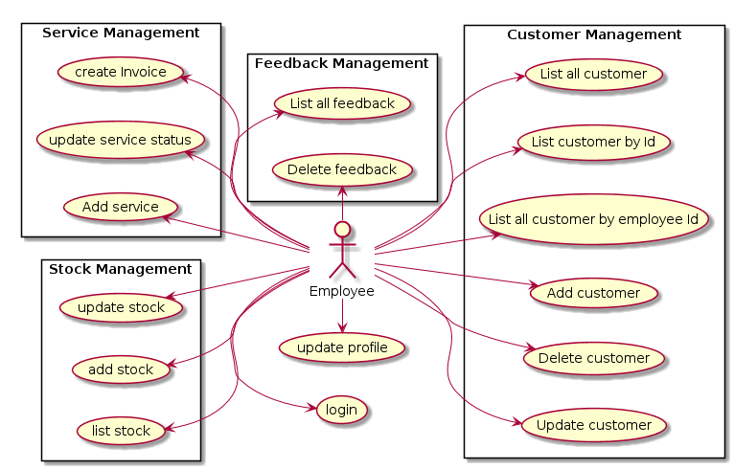

**PROJECT DESIGN**

**CLASS-DIAGRAM**

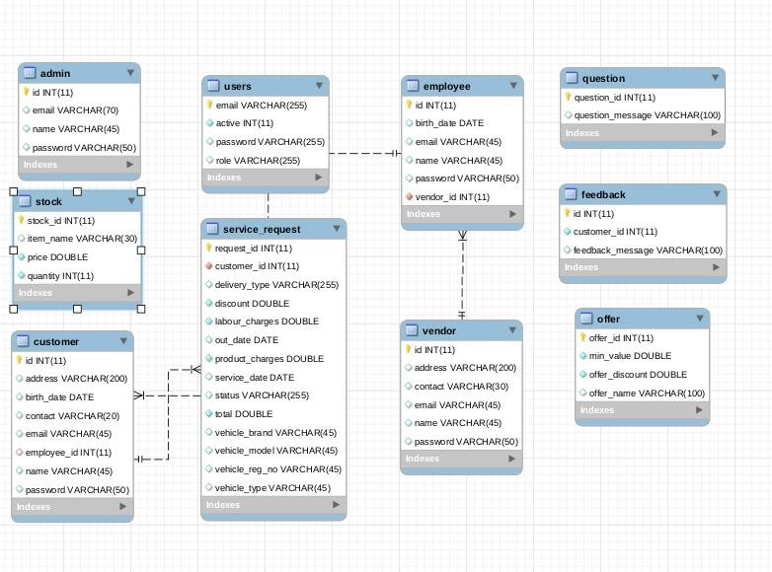

**ER-DIAGRAM**

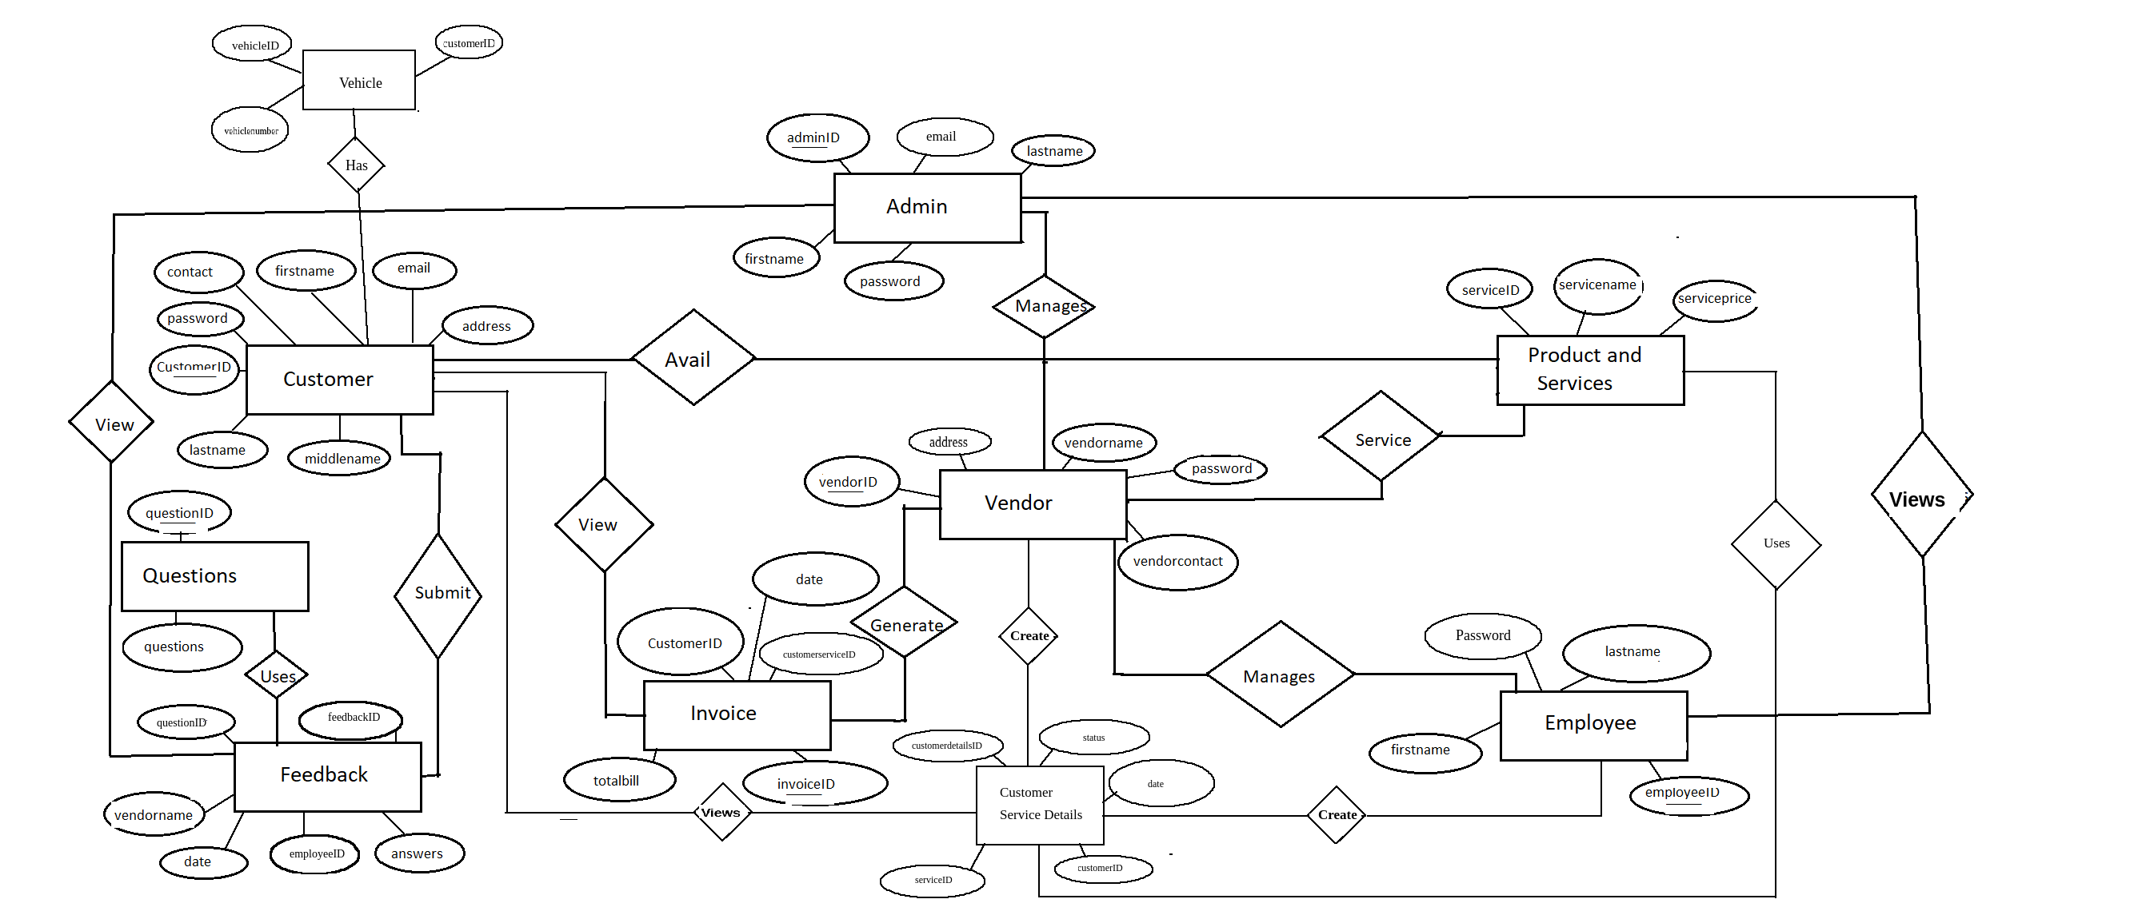

**DATABASE DESIGN**

1. **Users Table**

|  |  |  |  |  |  |
| --- | --- | --- | --- | --- | --- |
| **Field** | **Type** | **Null** | **Key** | **Default** | **Extra** |
| email | varchar(255) | NO | PRI | NULL |  |
| active | varchar(70) | NO |  | NULL |  |
| password | int(11) | YES |  | NULL |  |
| role | varchar(255) | YES |  | NULL |  |

1. **Admin**

|  |  |  |  |  |  |
| --- | --- | --- | --- | --- | --- |
| **Field** | **Type** | **Null** | **Key** | **Default** | **Extra** |
| id | int(11) | NO | PRI | NULL | auto_increament |
| email | varchar(70) | YES |  | NULL |  |
| name | varchar(45) | YES |  | NULL |  |
| password | varchar(50) | YES |  | NULL |  |

1. **Vendor**

|  |  |  |  |  |  |
| --- | --- | --- | --- | --- | --- |
| **Field** | **Type** | **Null** | **Key** | **Default** | **Extra** |
| id | int(11) | NO | PRI | NULL | auto_increament |
| address | varchar(200) | YES |  | NULL |  |
| contact | varchar(30) | YES |  | NULL |  |
| email | varchar(45) | YES |  | NULL |  |
| name | varchar(45) | YES |  | NULL |  |
| password | varchar(50) | YES |  | NULL |  |

1. **Employee**

|  |  |  |  |  |  |
| --- | --- | --- | --- | --- | --- |
| **Field** | **Type** | **Null** | **Key** | **Default** | **Extra** |
| id | int(11) | NO | PRI | NULL | auto_increament |
| birth_date | date | YES |  | NULL |  |
| email | varchar(45) | YES |  | NULL |  |
| name | varchar(45) | YES |  | NULL |  |
| password | varchar(50) | YES |  | NULL |  |
| vendor_id | int(11) | NO | MUL | NULL |  |

1. **Customer**

|  |  |  |  |  |  |
| --- | --- | --- | --- | --- | --- |
| **Field** | **Type** | **Null** | **Key** | **Default** | **Extra** |
| id | int(11) | NO | PRI | NULL | auto_increament |
| address | varchar(200) | YES |  | NULL |  |
| birth_date | date | YES |  | NULL |  |
| contact | varchar(20) | YES |  | NULL |  |
| email | varchar(45) | YES |  | NULL |  |
| employee_id | int(11) | NO | MUL | NULL |  |
| name | varchar(45) | YES |  | NULL |  |
| password | varchar(50) | YES |  | NULL |  |

1. **Feedback**

|  |  |  |  |  |  |
| --- | --- | --- | --- | --- | --- |
| **Field** | **Type** | **Null** | **Key** | **Default** | **Extra** |
| id | int(11) | NO | PRI | NULL | auto_increament |
| customer_id | int(11) | NO |  | NULL |  |
| feedback_message | varchar(100) | YES |  | NULL |  |

1. **Question**

|  |  |  |  |  |  |
| --- | --- | --- | --- | --- | --- |
| Field | Type | Null | Key | Default | Extra |
| question_id | int(11) | NO | PRI | NULL | auto_increament |
| feedback_message | varchar(100) | YES |  | NULL |  |

1. **Offer**

|  |  |  |  |  |  |
| --- | --- | --- | --- | --- | --- |
| **Field** | **Type** | **Null** | **Key** | **Default** | **Extra** |
| offer_id | int(11) | NO | PRI | NULL | auto_increament |
| min_value | double | NO |  | NULL |  |
| offer_discount | double | NO |  | NULL |  |
| offer_name | varchar(100) | YES |  | NULL |  |

1. **Service Request**

|  |  |  |  |  |  |
| --- | --- | --- | --- | --- | --- |
| **Field** | **Type** | **Null** | **Key** | **Default** | **Extra** |
| request_id | int(11) | NO | PRI | NULL | auto_increament |
| customer_id | int(11) | NO | MUL | NULL |  |
| delivery_type | varchar(255 | YES |  | NULL |  |
| discount | double | NO |  | NULL |  |
| labour_charges | double | NO |  | NULL |  |
| out_date | date | YES |  | NULL |  |
| product_charges | double | NO |  | NULL |  |
| service_date | date | YES |  | NULL |  |
| status | varchar(255) | YES |  | NULL |  |
| total | double | NO |  | NULL |  |
| vehicle_brand | varchar(45) | YES |  | NULL |  |
| vehicle_model | varchar(45) | YES |  | NULL |  |
| vehicle_reg_no | varchar(45) | YES |  | NULL |  |
| vehicle_type | varchar(45) | YES |  | NULL |  |

1. **Stock**

|  |  |  |  |  |  |
| --- | --- | --- | --- | --- | --- |
| **Field** | **Type** | **Null** | **Key** | **Default** | **Extra** |
| stock_id | int(11) | NO | PRI | NULL | auto_increament |
| item_name | varchar(30) | YES | UNI | NULL |  |
| price | double | NO |  | NULL |  |
| quantity | int(11) | NO |  | NULL |  |

**PROJECT SCREENSHOTS**

**Website Home**

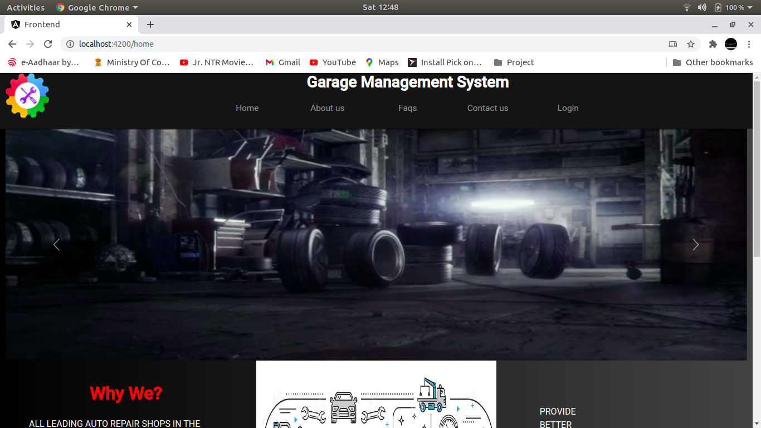

**About-us**

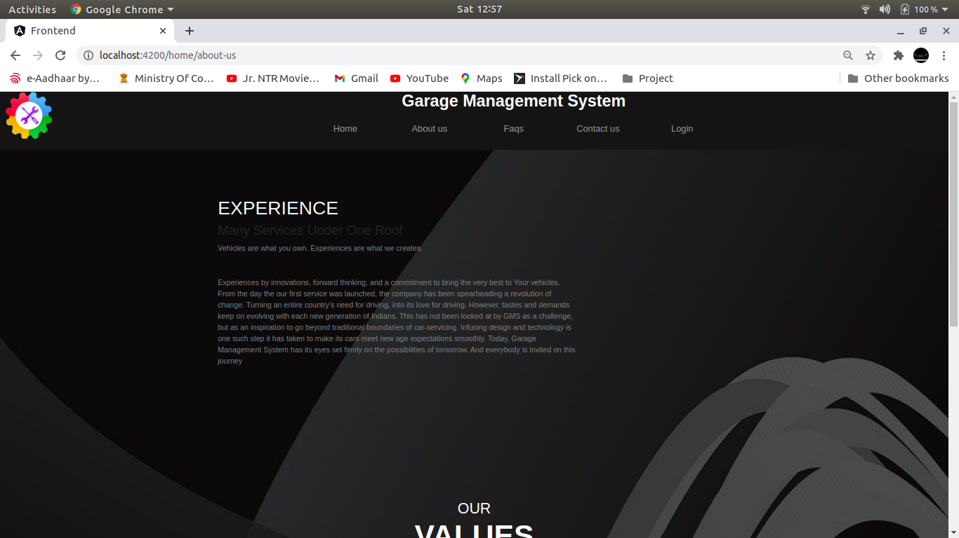

**Frequently Asked Questions**

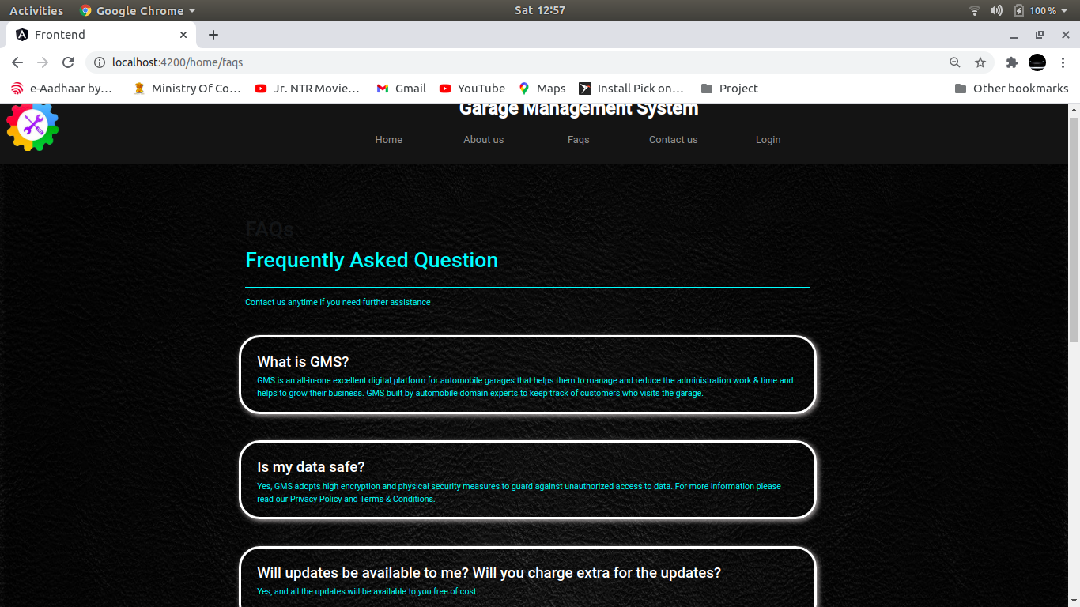

**Login**

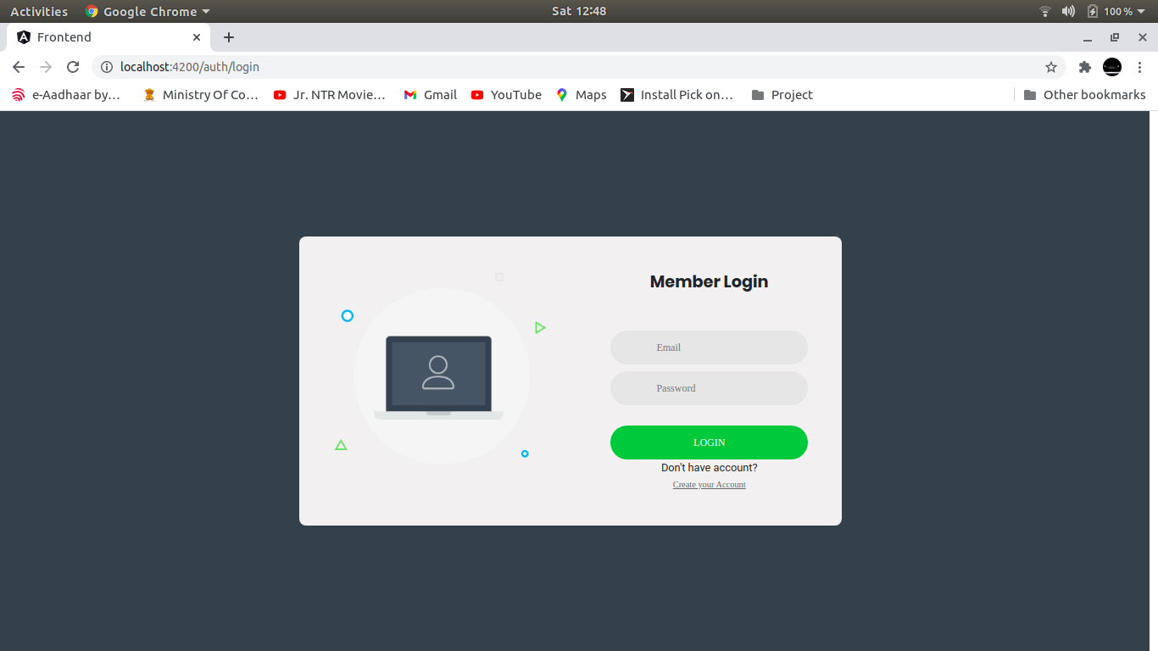

**Admin**

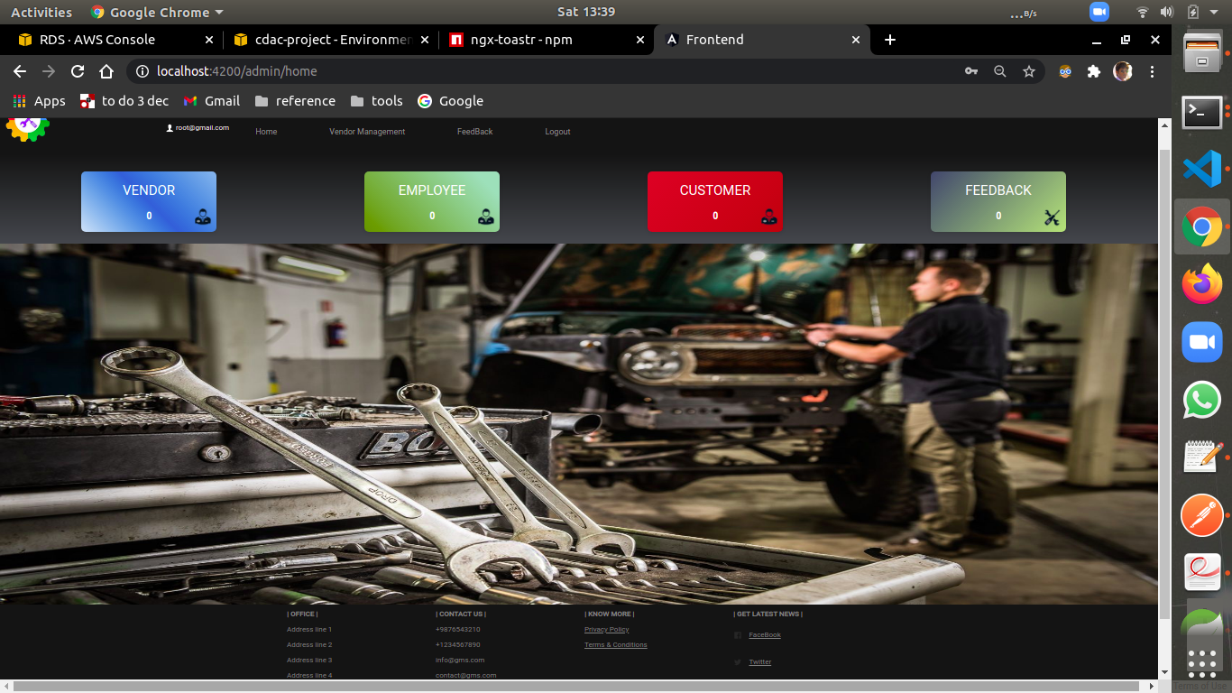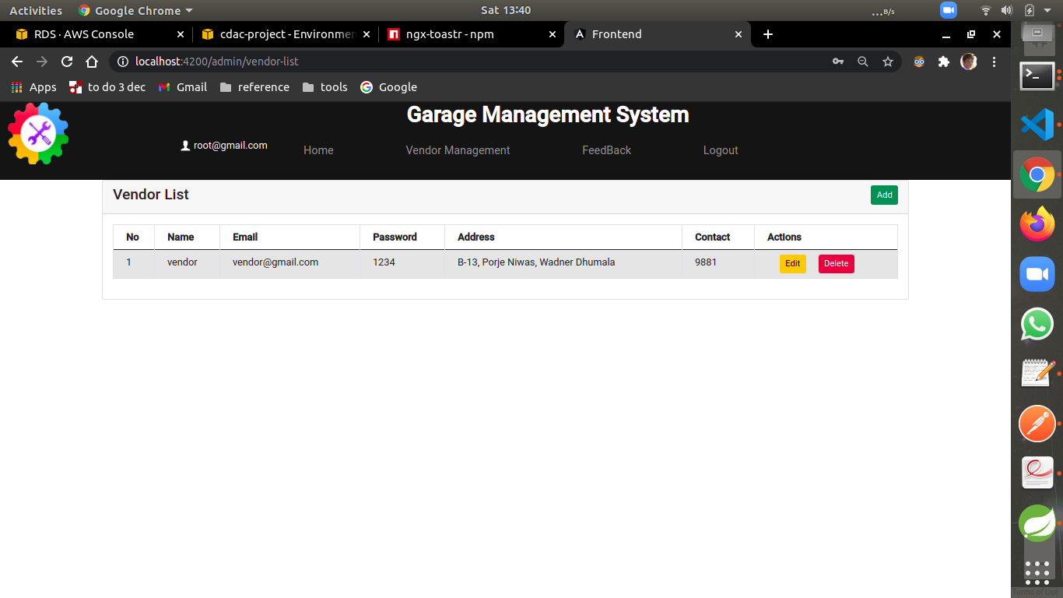

**Vendor**

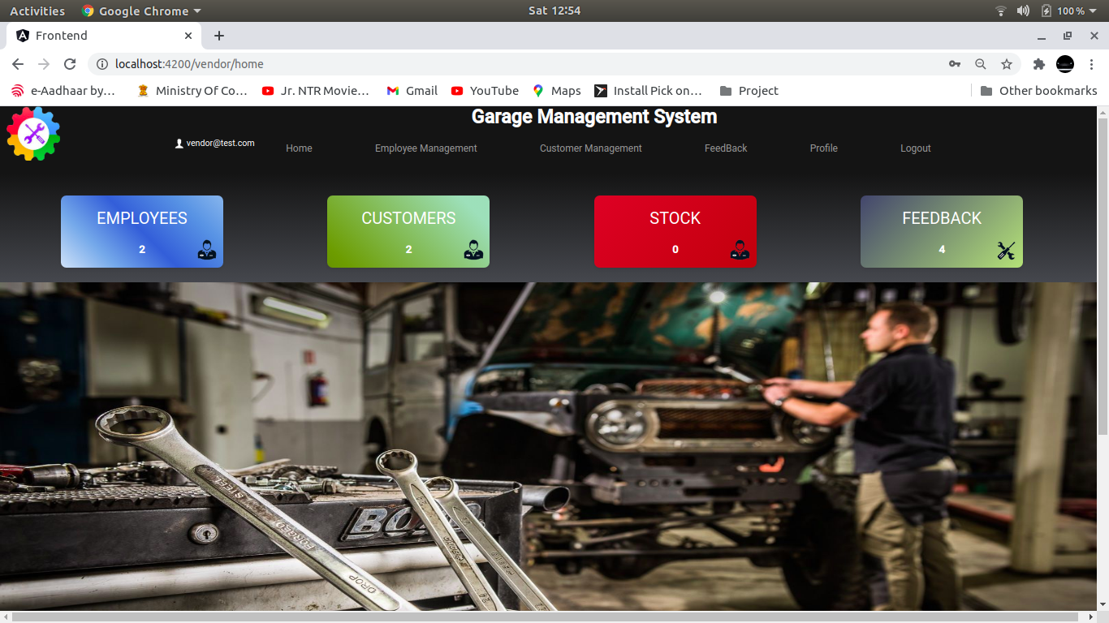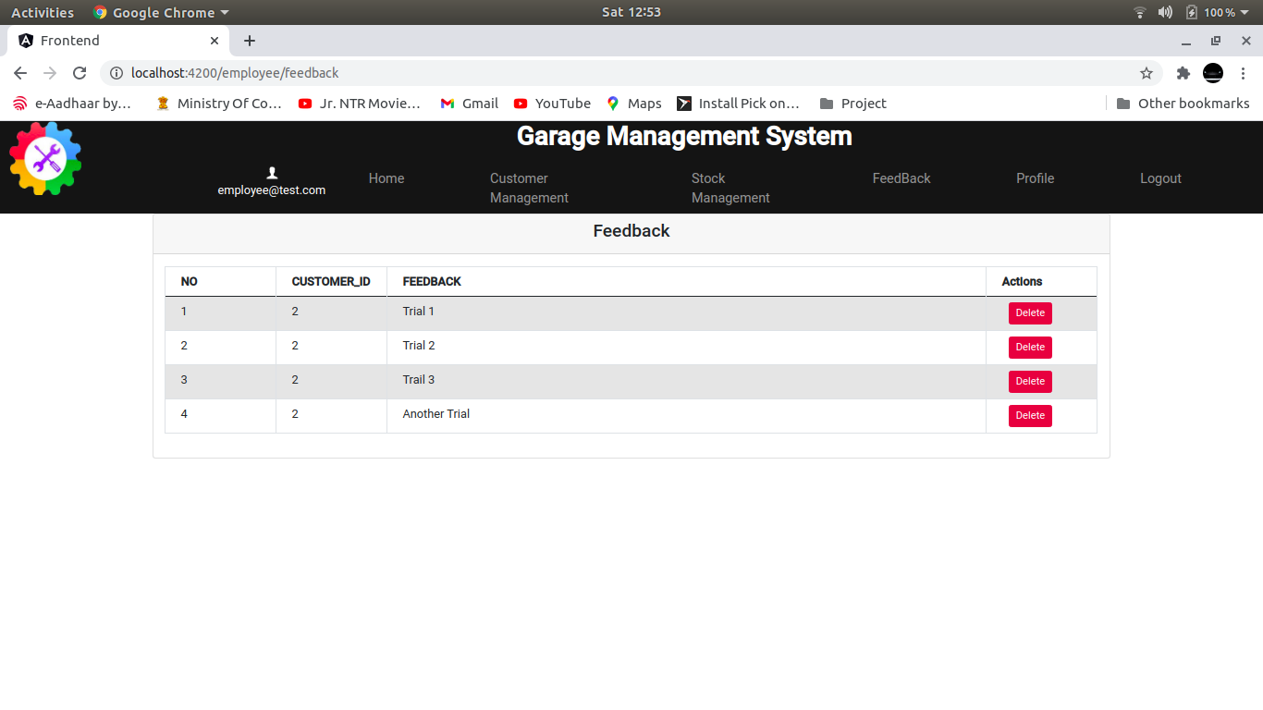

**Employee**

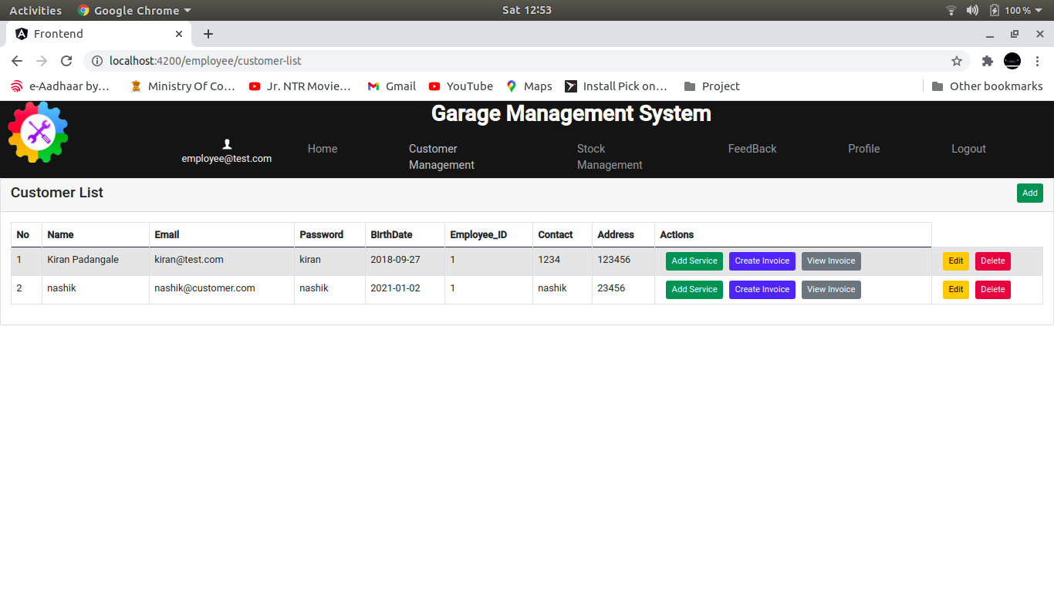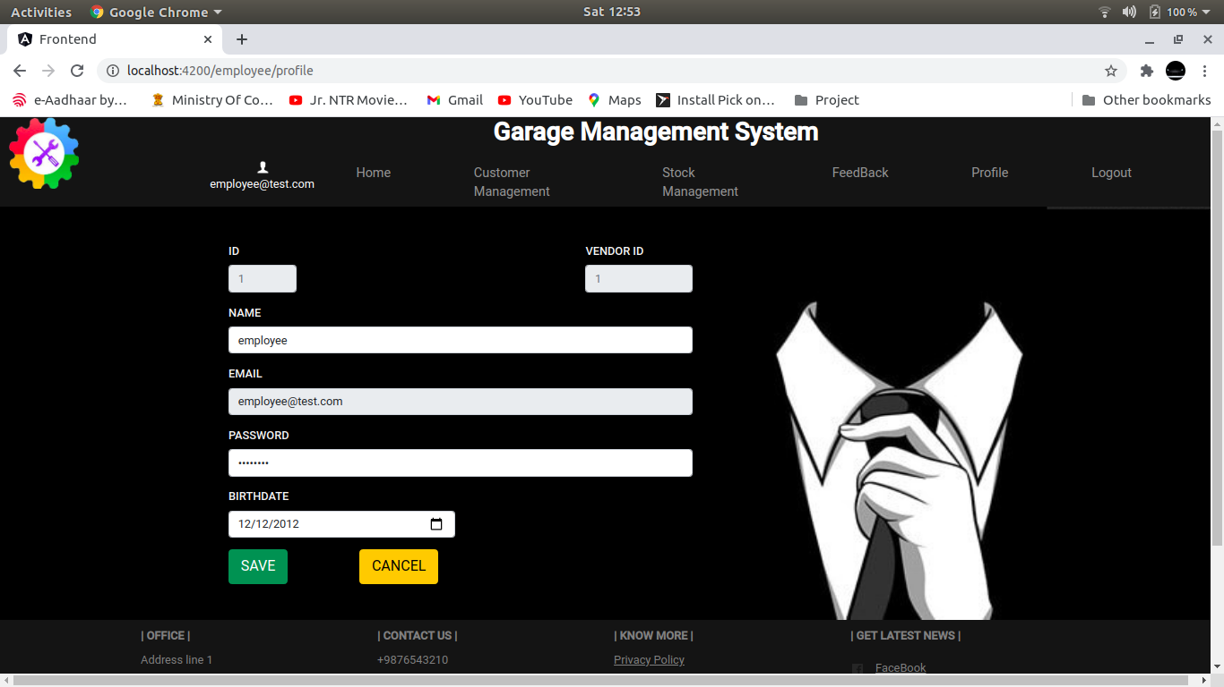

**Customer**

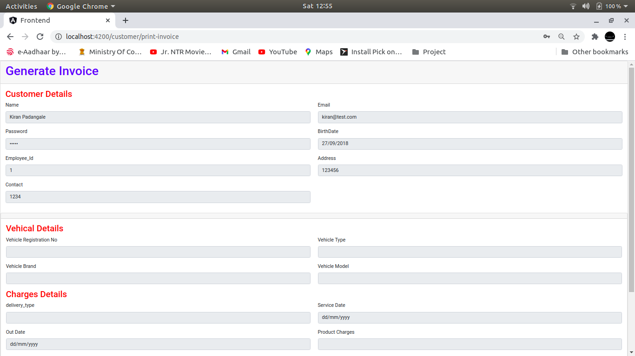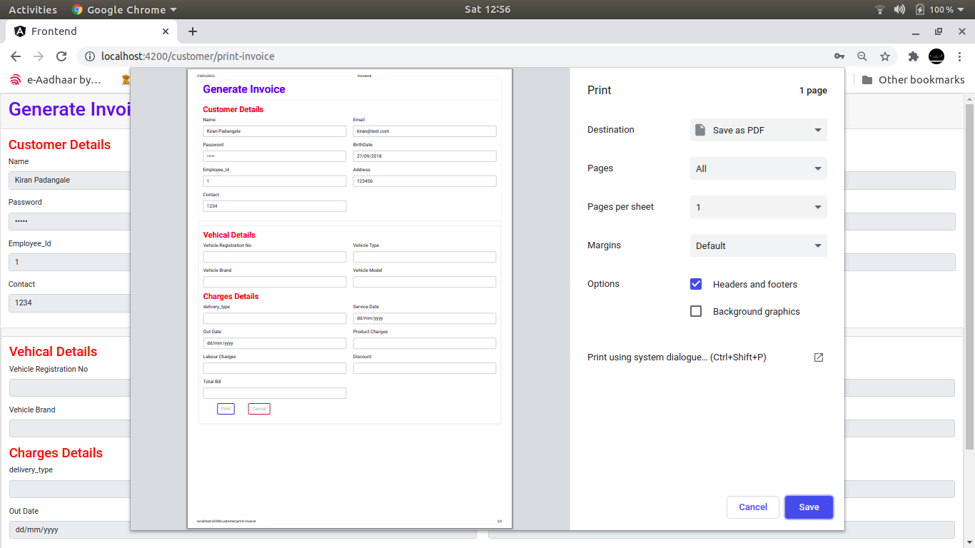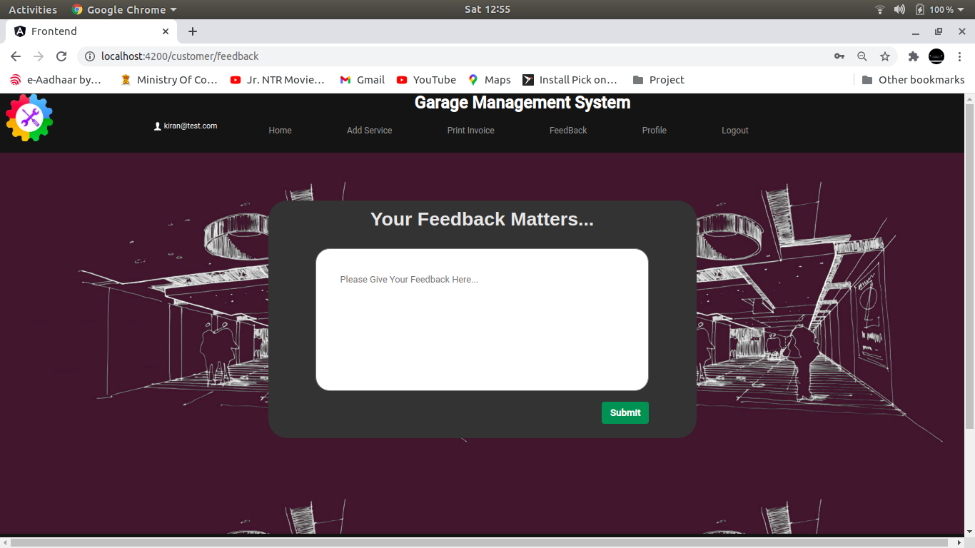

**TESTING**

To build up our project we used software testing process for executing a program with the intent of finding error that is uncovering errors in a program makes it a feasible task and also typing to find the errors (whose presence is assumed) in a program. As it is a destructive process.

Types of testing we use in our project

Here we just mentioned that how the testing is related to this software and in which way we have test the software? In our project we have used five types of testing this are listed below –

**UNIT TESTING –**

Unit testing where individual program units or object class are tested here by using this testing we have focus on testing functionality of the methods.

**MODULE TESTING–**

Where this is the combination of unit program is called module. Here we tested unit program is where the module program have dependency.

**SUB SYSTEM TESTING –**

Then we combined some module for the preliminary system testing in out project.

**SYSTEM TESTING –**

Where it is combination of two or more sub system and then it is tested here we tested the entire system a per requirement.

**ACEEPTANCE TESTING –**

Normally this type of testing is done to verify if system meets the customer specified requirements. After submitting this project to the user then they tested and to determine whether to accept the application. It is the system of testing performed by the customer to determine where they should accept the delivery of system.

**CONCLUSION**

Currently small and medium scale service center don’t have synchronization between their task and customer.

By making online vehicle management system we have solved the problem from vendor and customer end and more convenience is added to the existing system.

In future scope this system will be available with large scale database and can accommodate many customers and vendors.

To find the location of new customer for that particular city we can add Google API to find nearest service center.

This system can also be developed on mobile application so that it can be access remotely.